**IMPORTANT – before you start doing your solution, MUST do the following steps:**

1. Create your MS SQL database named **JobDB by running code in script**

**JobDB.sql.**

1. Copy given file **DBContext.java (2)** to source package (src\java) folder under your web project. You might need to use and name a java package for (2), free to set the name of package.
2. **You MUST use DBContext.java for your all database connection.**
3. Set the home page/default for your project as **AddJob.jsp** page.

**Questions:**

Create a **AddJob.jsp** page with GUI as below figures **(0.25 Point)**:

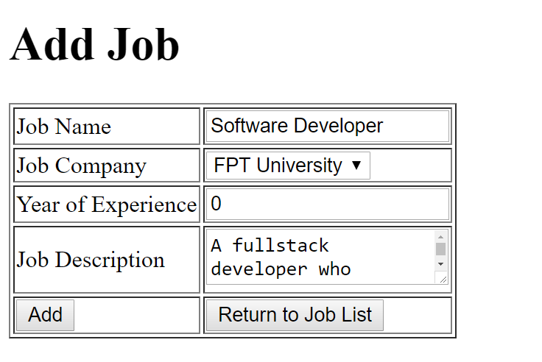

**Requirements:**

* Value for Year of Experience must be numerical (**0.25 Point)**

When the users click on **Add** button, validate the data on the input form as rules:

* Require data for all text fields (**0.75 Point - 0.25 Point for each error message**).

When the validation is correct.

Add information on input form to **Job** table (**0.25 Point**) and browse to **ListJob.jsp** page **(0.25 Point)**.

When users click on the **“Return To Job List”** button, browse to **ListJob.jsp** page **(0.25 Point)** which will be shown as below**.**

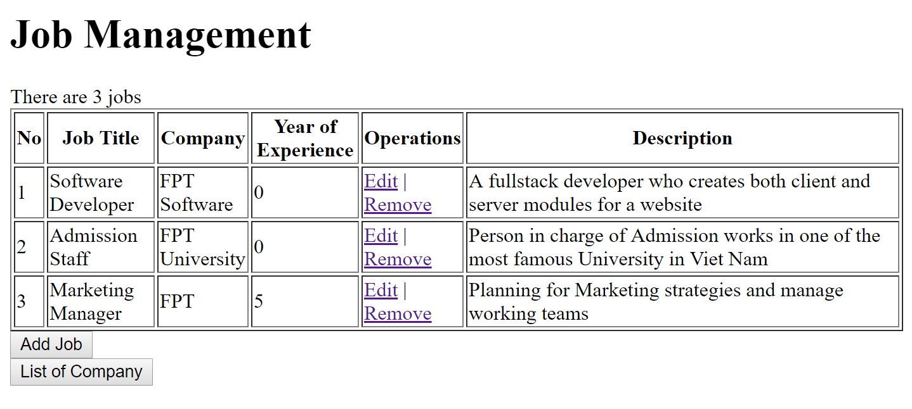

*The table must have the same columns with one in above figures.*

**Requirements:**

* Output all Jobs in Job table to **ListJob.jsp** as above table (**0.5 Point**).
* Calculate and display the number of Jobs of result **(0.25 Point).**
* Values for Company should be corresponding to the Company Name in Database (**0.25 Point**).

When users click on button “List of Company”, browse to **ListCompany.jsp** which will output information of all companies **(0.5 Point)**,

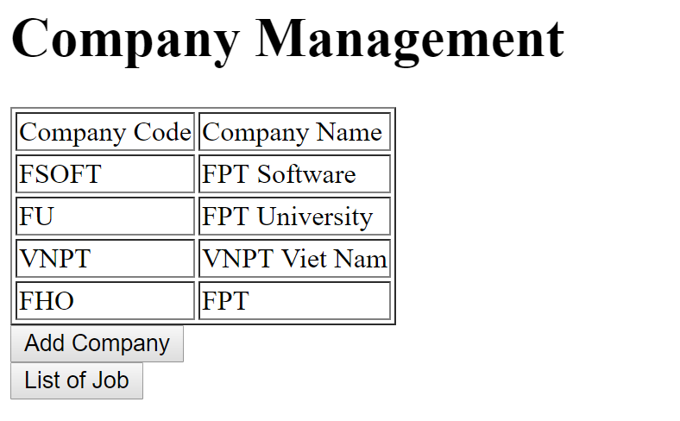

When users click on **List Of Job,** browse to **ListJob**.**jsp** page **(0.25 Point).**

When users click on **Add Company,** browse to **AddCompany.jsp** which will be used to add a new company into the database **(0.25 Point)**

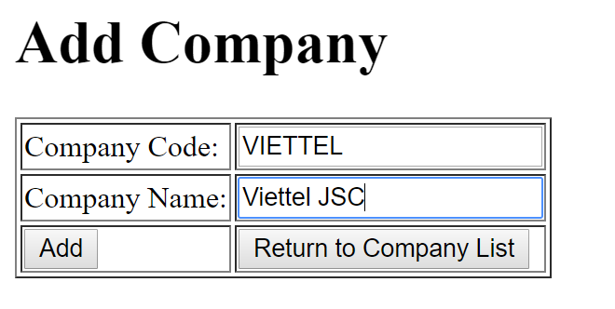

**Requirements:**

* Add information on input form to **Company** table (**0.5 Point**) and browse to **ListCompany.jsp** page **(0.25 Point)**.
* When users click on the **“Return To Company List”** button, browse to **ListCompany.jsp** page **(0.25 Point)** which will be shown as below**.**

On the “Job List” page, when the users click on the link **Remove**, the corresponding record will be removed from the database, and the list will be refreshed to reflect the result. **(0.25 Point)**

When users click on the link **Edit**, browse to **EditJob.jsp** page **(0.25 Point)**

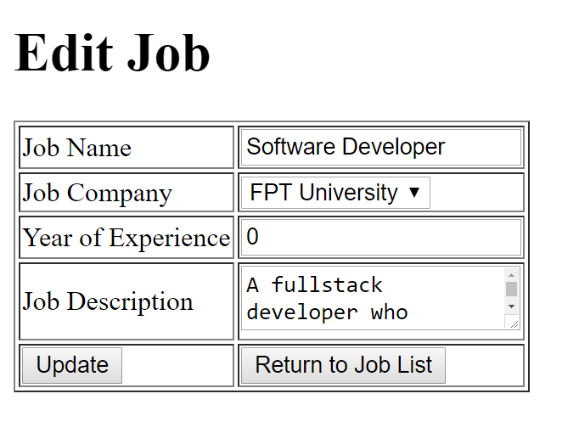

**Requirements:**

* Value for Year of Experience must be numerical (**0.25 Point)**
* When user click on “Update” button, save the edited information into the database **(0.5 Point)**
* When user click on “Return To Job List”, browse **ListJob.jsp** page. **(0.25 Point)**